

MATLAB-Experiment 3b

Maxima and minima of a function of two variables



BIMAL PARAJULI

20BDS0405

Department of Mathematics

School of Advanced Sciences

MAT 1011 – Calculus for Engineers (MATLAB)

Experiment 3-B

Maxima and minima of a function of two variables

Prepared by: Bimal parajuli

Registration Number: 20BDS0405

1. **Find the maxima and minima for the following functions**

**f(x,y)=x4 + y4 –x2 –y2 +1**

**CODES:**

clc

close all

clc

syms x y

f(x,y)=input('Enter function f(x,y) to calculate the maxima/minima');

p=diff(f,x); %df/dx

q=diff(f,y); %df/dy

[ax,ay]=solve(p,q);

ax=double(ax);

ay=double(ay);

r=diff(p,x); %d2f/dx2

s=diff(p,y); %d2f/dxdy

t=diff(q,y); %d2f/dy2

D=r*t-s^2;

figure

fsurf(f);

xlabel('X-axis');

ylabel('Y-axis');

zlabel('Z-axis');

legstr={'Plot of the given function'};

for i=1:size(ax)

t1=D(ax(i),ay(i));

t2=r(ax(i),ay(i));

t3=f(ax(i),ay(i));

if (double(t1)==0)

sprintf('At (%f,%f) further investigation needed',ax(i),ay(i))

legstr=[legstr,{'Case to investigate further'}];

mkr='ko';

elseif (double(t1)<0)

sprintf('The point(%f,%f) is a saddle point',ax(i),ay(i))

legstr=[legstr,{'Saddle point'}];

mkr='bv';

else

if (double(t2)<0)

sprintf('The maximum value is %f at the point(%f,%f)',t3,ax(i),ay(i))

legstr=[legstr,{'maximum value of function'}];

mkr='g+';

else

sprintf('The minimum value is %f at the point(%f,%f)',t3,ax(i),ay(i))

legstr=[legstr,{'minimum value of the function'}];

mkr='r+';

end

end

hold on;

plot3(ax(i),ay(i),t3,mkr,'linewidth',3);

end

legend(legstr,'location','best');

title('Plot of f(x,y) showing maxima/minima')

**INPUT:**

Enter function f(x,y) to calculate the maxima/minima

x^4 + y^4 -x^2 -y^2 +1

**OUTPUT:**

ans =  
  
 'The maximum value is 1.000000 at the point(0.000000,0.000000)'  
  
  
ans =  
  
 'The minimum value is 0.500000 at the point(-0.707107,-0.707107)'  
  
  
ans =  
  
 'The minimum value is 0.500000 at the point(0.707107,-0.707107)'  
  
  
ans =  
  
 'The minimum value is 0.500000 at the point(-0.707107,0.707107)'

ans =  
  
 'The minimum value is 0.500000 at the point(0.707107,0.707107)'  
  
  
ans =  
  
 'The point(-0.707107,0.000000) is a saddle point'  
  
  
ans =  
  
 'The point(0.707107,0.000000) is a saddle point'  
  
  
ans =  
  
 'The point(0.000000,-0.707107) is a saddle point'  
  
  
ans =  
  
 'The point(0.000000,0.707107) is a saddle point'

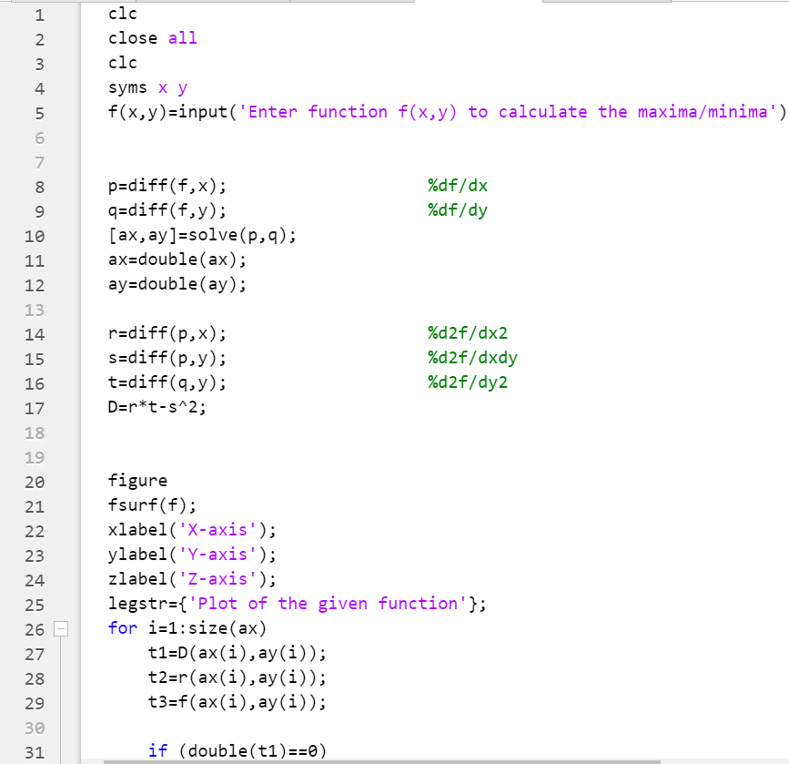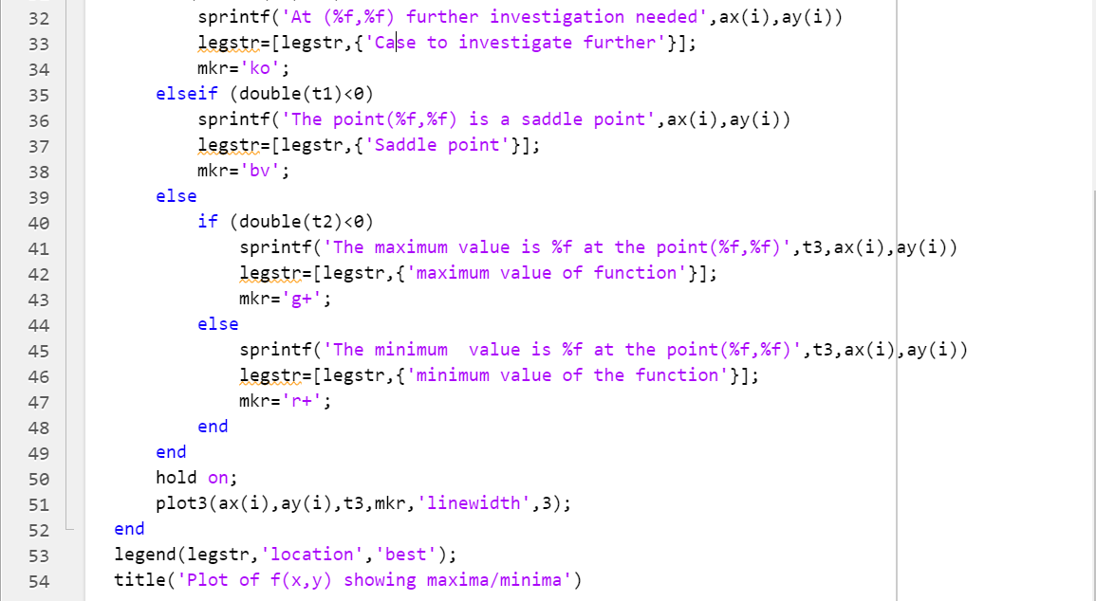

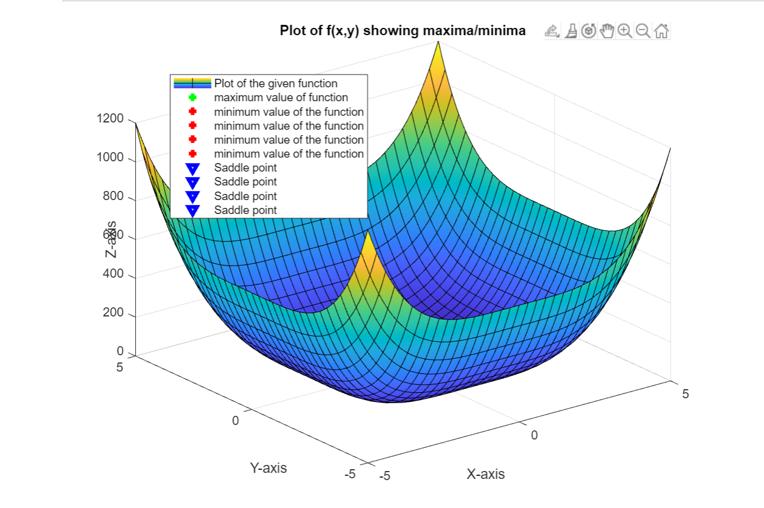

1. **Find the maxima and minima for the following functions**

**x^3 + 3*x*y^2 - 15*x^2 - 15*y^2 +72*x**

**CODES:**

clc

close all

clc

syms x y

f(x,y)=input('Enter function f(x,y) to calculate the maxima/minima');

p=diff(f,x); %df/dx

q=diff(f,y); %df/dy

[ax,ay]=solve(p,q);

ax=double(ax);

ay=double(ay);

r=diff(p,x); %d2f/dx2

s=diff(p,y); %d2f/dxdy

t=diff(q,y); %d2f/dy2

D=r*t-s^2;

figure

fsurf(f);

xlabel('X-axis');

ylabel('Y-axis');

zlabel('Z-axis');

legstr={'Plot of the given function'};

for i=1:size(ax)

t1=D(ax(i),ay(i));

t2=r(ax(i),ay(i));

t3=f(ax(i),ay(i));

if (double(t1)==0)

sprintf('At (%f,%f) further investigation needed',ax(i),ay(i))

legstr=[legstr,{'Case to investigate further'}];

mkr='ko';

elseif (double(t1)<0)

sprintf('The point(%f,%f) is a saddle point',ax(i),ay(i))

legstr=[legstr,{'Saddle point'}];

mkr='bv';

else

if (double(t2)<0)

sprintf('The maximum value is %f at the point(%f,%f)',t3,ax(i),ay(i))

legstr=[legstr,{'maximum value of function'}];

mkr='g+';

else

sprintf('The minimum value is %f at the point(%f,%f)',t3,ax(i),ay(i))

legstr=[legstr,{'minimum value of the function'}];

mkr='r+';

end

end

hold on;

plot3(ax(i),ay(i),t3,mkr,'linewidth',3);

end

legend(legstr,'location','best');

title('Plot of f(x,y) showing maxima/minima')

**INPUT:**

Enter function f(x,y) to calculate the maxima/minima

x^3 + 3*x*y^2 - 15*x^2 - 15*y^2 +72*x

**OUTPUT:**

ans =  
  
 'The maximum value is 112.000000 at the point(4.000000,0.000000)'  
  
  
ans =  
  
 'The minimum value is 108.000000 at the point(6.000000,0.000000)'  
  
  
ans =  
  
 'The point(5.000000,-1.000000) is a saddle point'  
  
  
ans =  
  
 'The point(5.000000,1.000000) is a saddle point'

